SOP: AWS CloudWatch Monitoring and Alerting for EC2 & Lambda
1. Objective
To monitor AWS resources such as EC2 instances and Lambda functions using Amazon CloudWatch, create alarms based on resource utilization, and receive notifications when predefined thresholds are exceeded.

2. Scope
This SOP covers:
- EC2 Monitoring using CloudWatch
- CPU Utilization Alarms
- SNS Notifications
- Lambda Monitoring
- CloudWatch Logs
- Stress Testing Validation
- Troubleshooting

3. Prerequisites
AWS Resources
- AWS Account
- Running EC2 Instance
- IAM Permissions
- Amazon CloudWatch Access
- Amazon SNS Topic
- AWS Lambda Function (optional)

4. Architecture:
EC2 Instance
│
▼
CloudWatch Metrics
│
▼
CloudWatch Alarm
│
▼
SNS Topic
│
▼
Email Notification

5. Procedure –
EC2 Monitoring
Step 1: Open CloudWatch
- Login to AWS Console
- Search for CloudWatch
- Navigate to: CloudWatch → Alarms
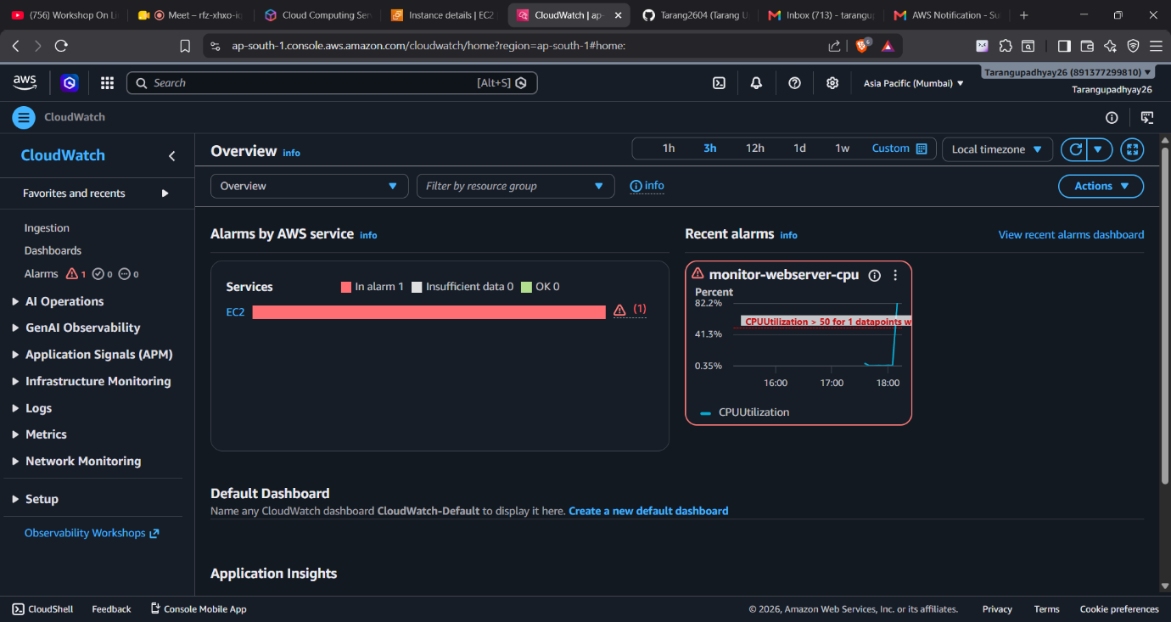

Step 2: Create Alarm
Click:
Create Alarm
Select:
Classic
Click:
Select Metric
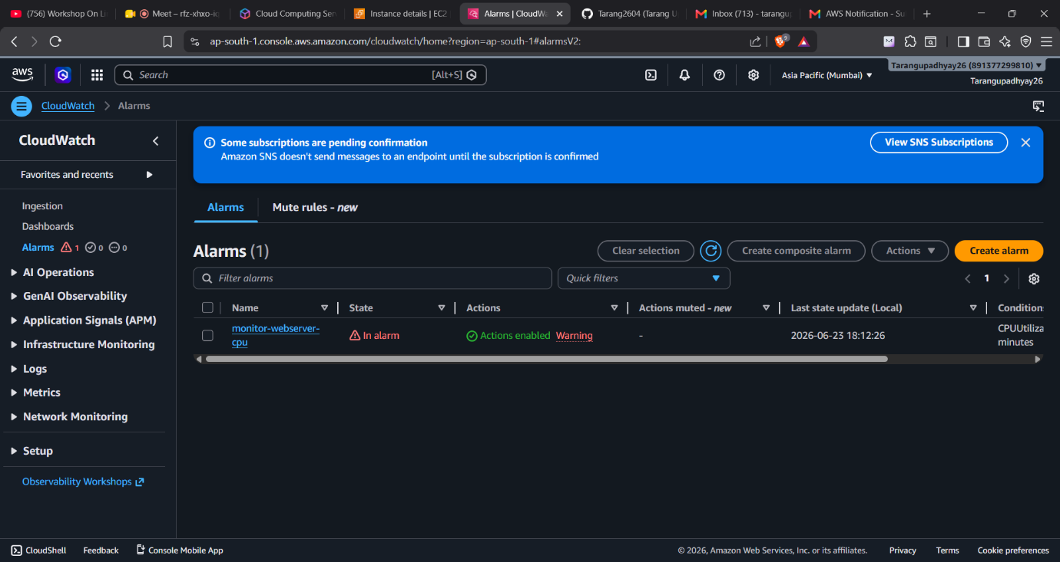

Step 3: Choose EC2 Metric
Navigate: 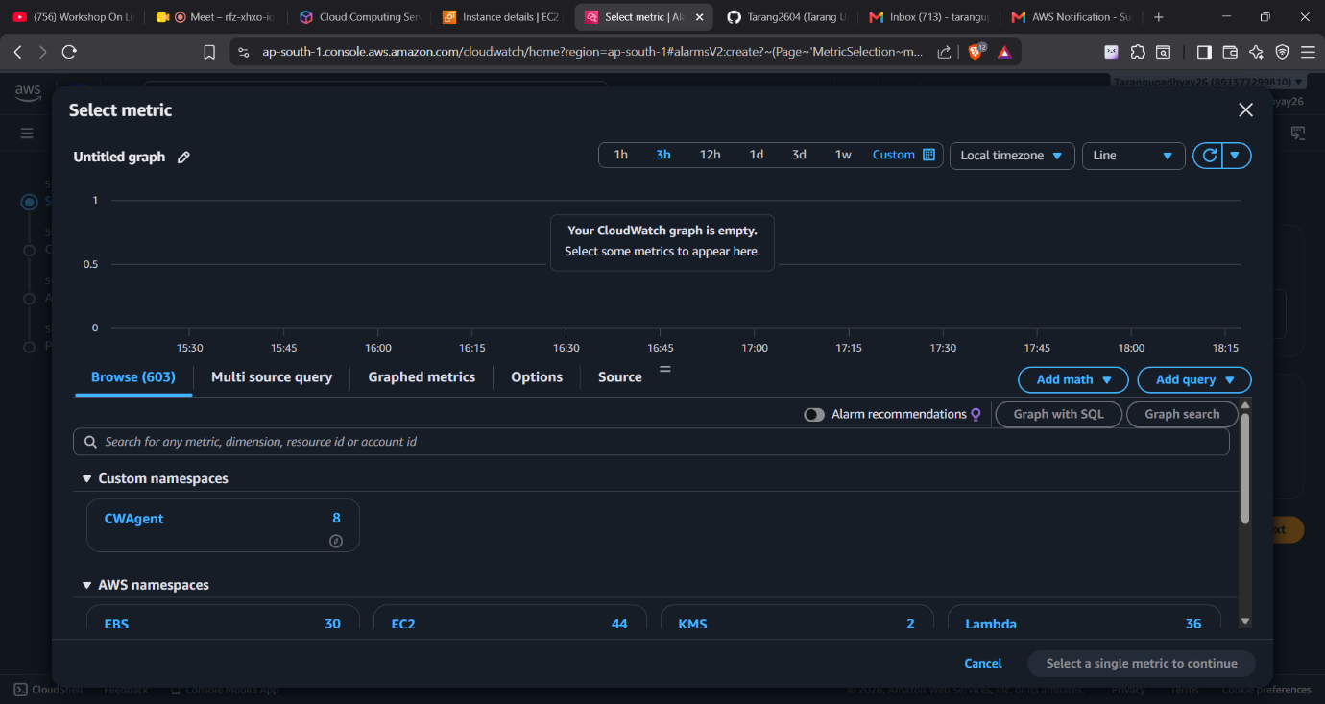
EC2
→ Per-Instance Metrics
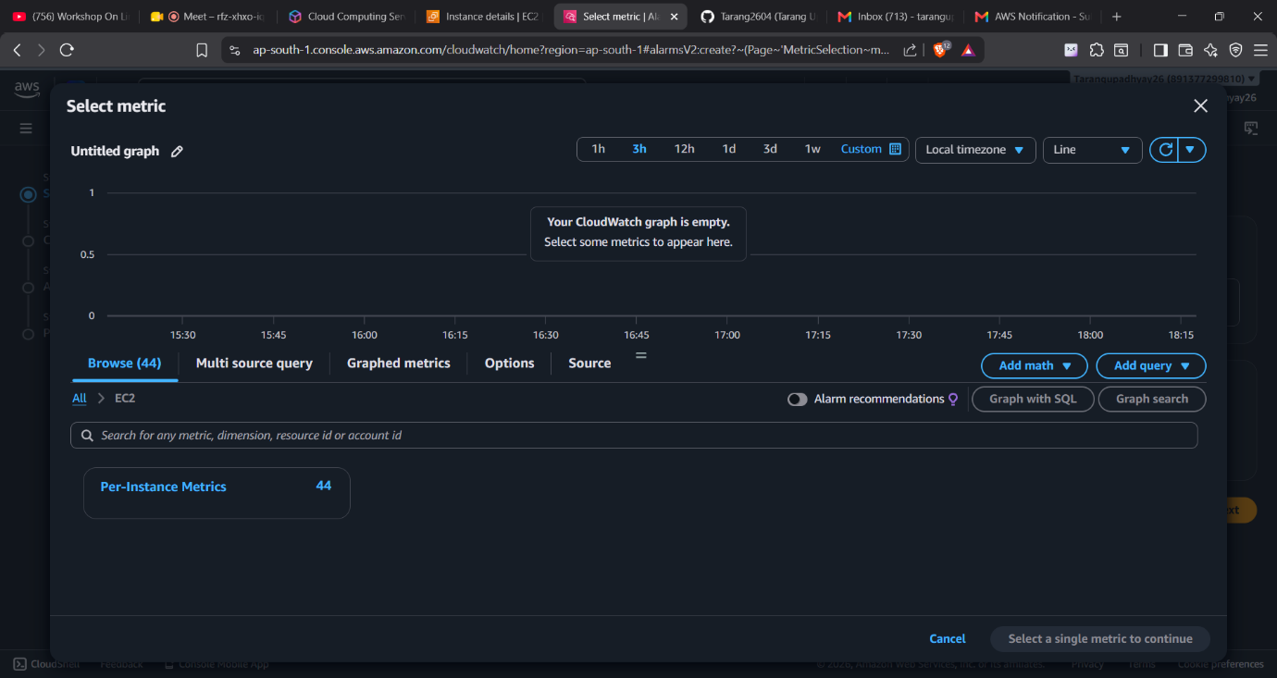

→ CPUUtilization
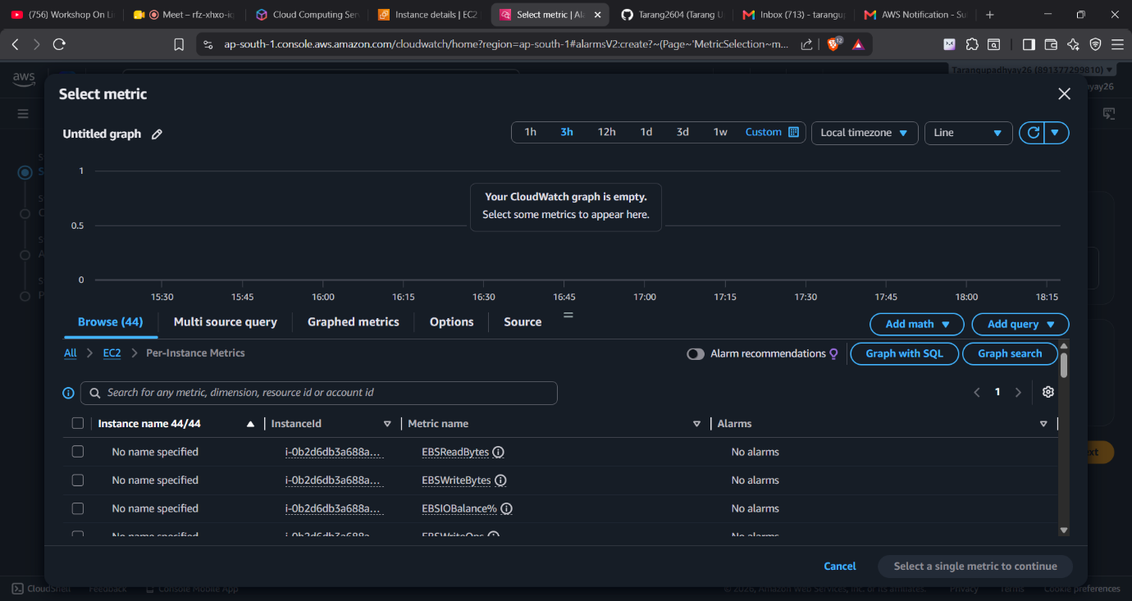

Select your instance:
my-web-server1
Click:
Select Metric

Step 4: Configure Threshold
Metric:
CPUUtilization
Condition:
Greater Than
Threshold:
50%
Evaluation Period:
1 Datapoint
Meaning:
Trigger alarm if CPU exceeds 50%

Step 5: Configure Notification
Choose:
In Alarm State
Create SNS Topic:
EC2-CPU-Alerts
Add Email:
your-email@example.com
Confirm subscription from email inbox.
Important:
Without confirmation SNS notifications will remain pending.

Step 6: Create Alarm
Alarm Name:
monitor-webserver-cpu
Description:
Monitor EC2 CPU utilization and notify when CPU exceeds 50%.
Click:
Create Alarm
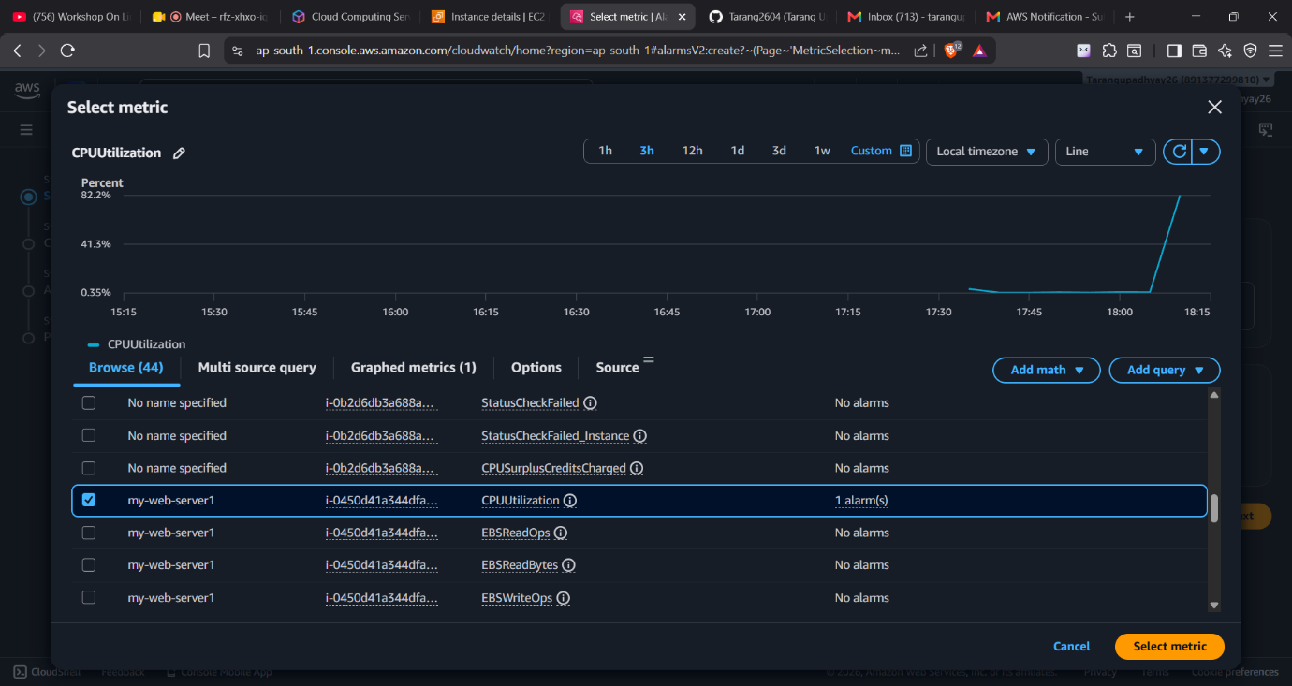

6.1 Validate Alarm
SSH into EC2:
ssh -i webserver2.pem ec2-user@<public-ip>
Update packages:
sudo yum update -y
Install stress tool:
sudo yum install stress -y
Generate CPU Load:
sudo stress --cpu 8 -v --timeout 3000s
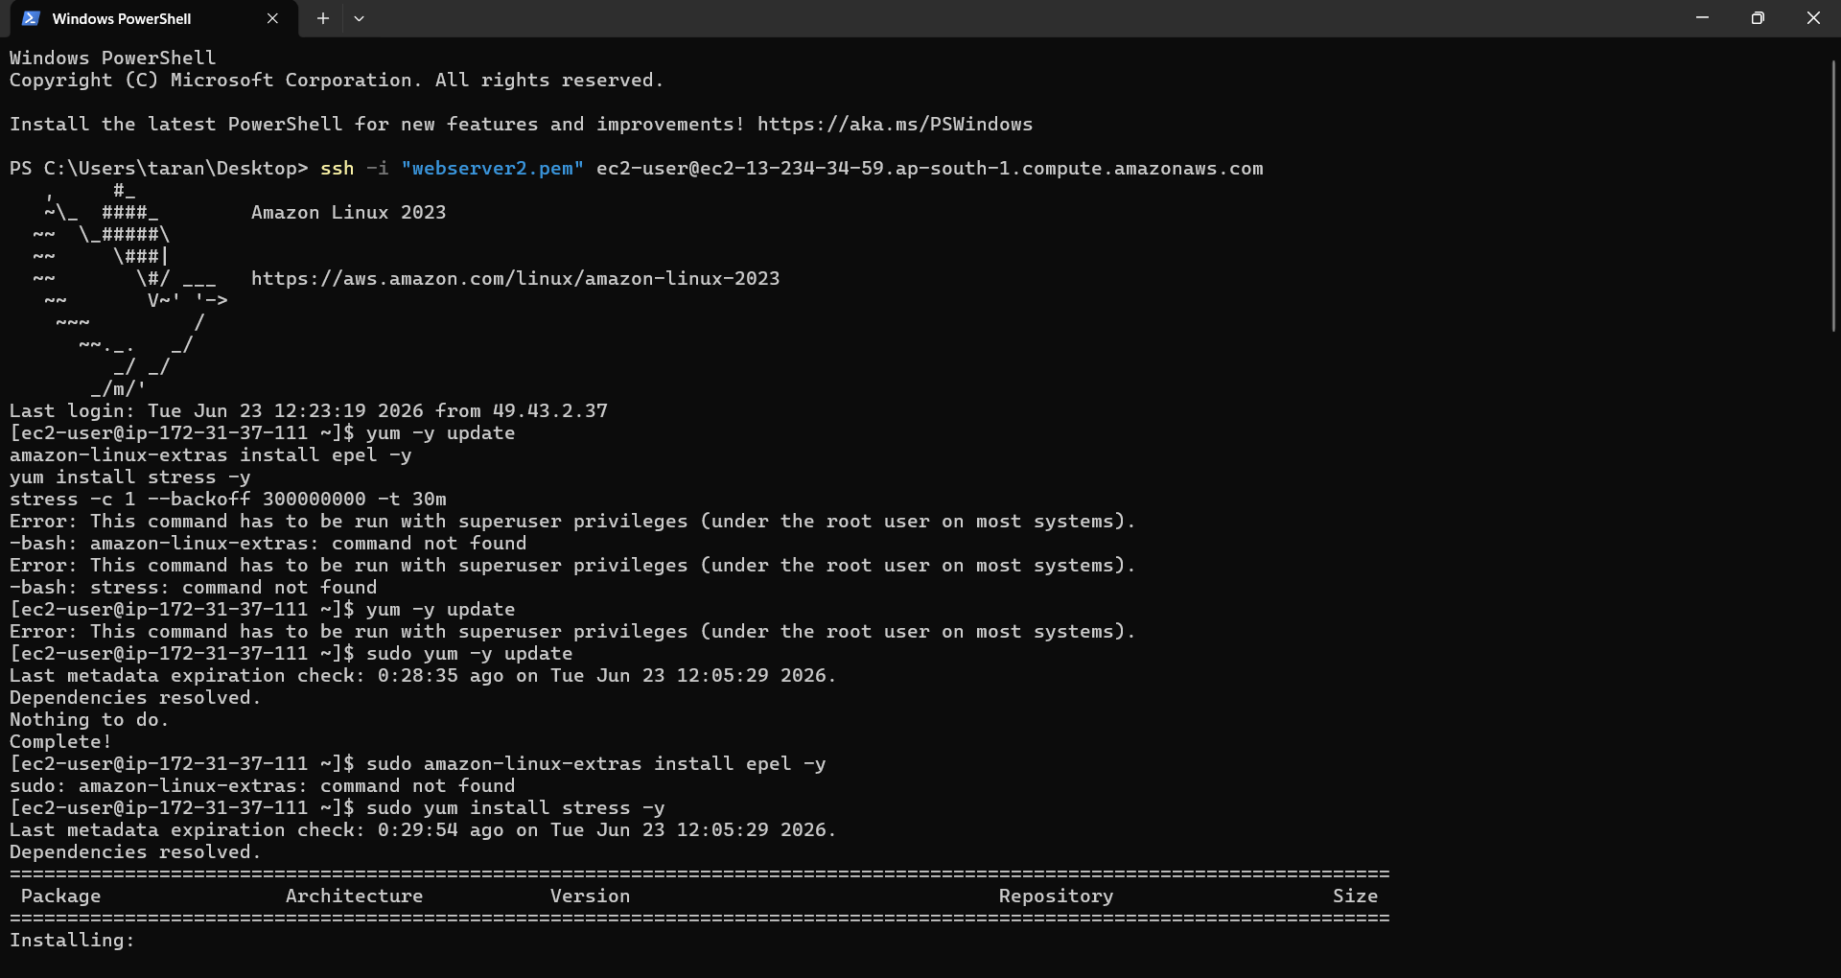

This command:
- Creates 8 CPU workers
- Consumes CPU resources
- Increases CPU utilization

7. Monitor Results
Navigate:
CloudWatch
→ Alarms
Expected State:
In Alarm
Observed Result:
CPU Utilization = 82.2%
Alarm Triggered Successfully.
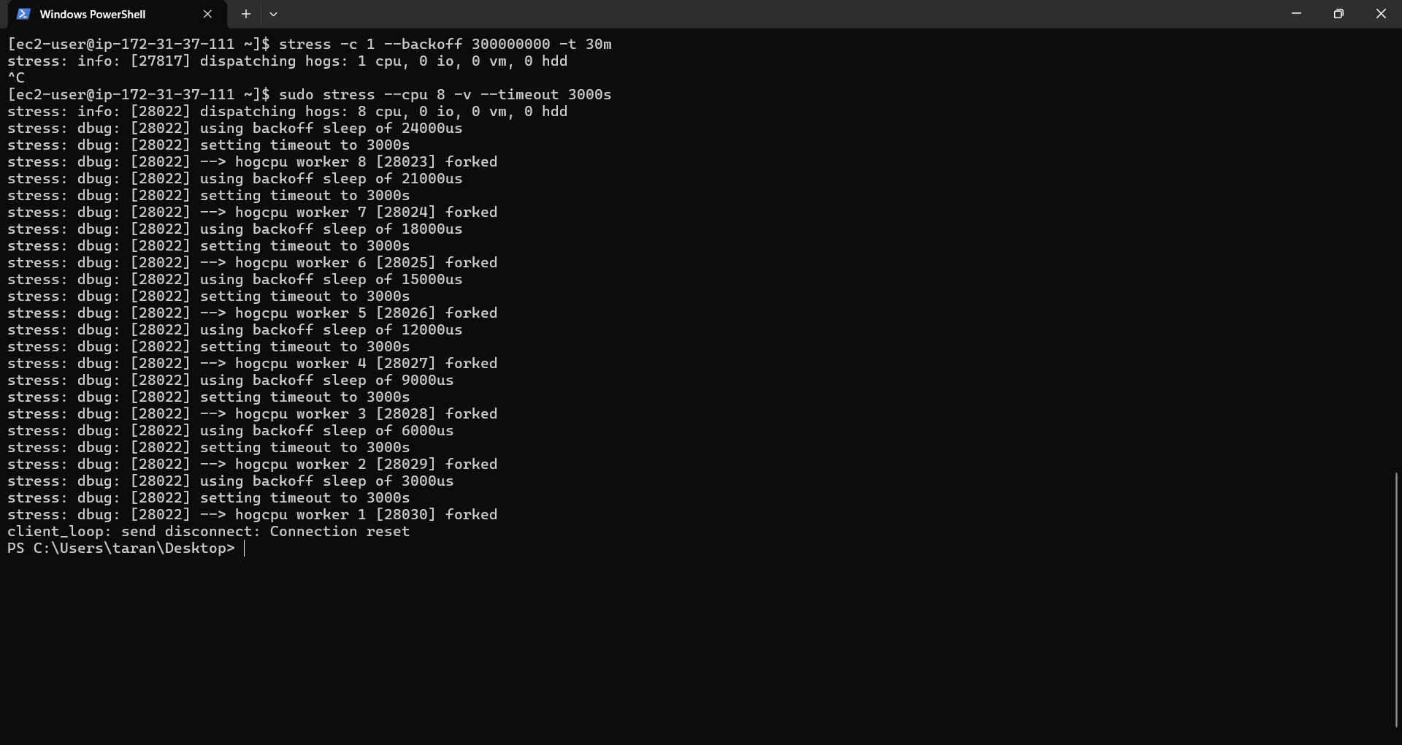

8. Verify Email Notification
Check email inbox.
Expected Message:
AWS Notification Message
Alarm Name:
monitor-webserver-cpu
State:
ALARM
Reason:
CPUUtilization > 50%

